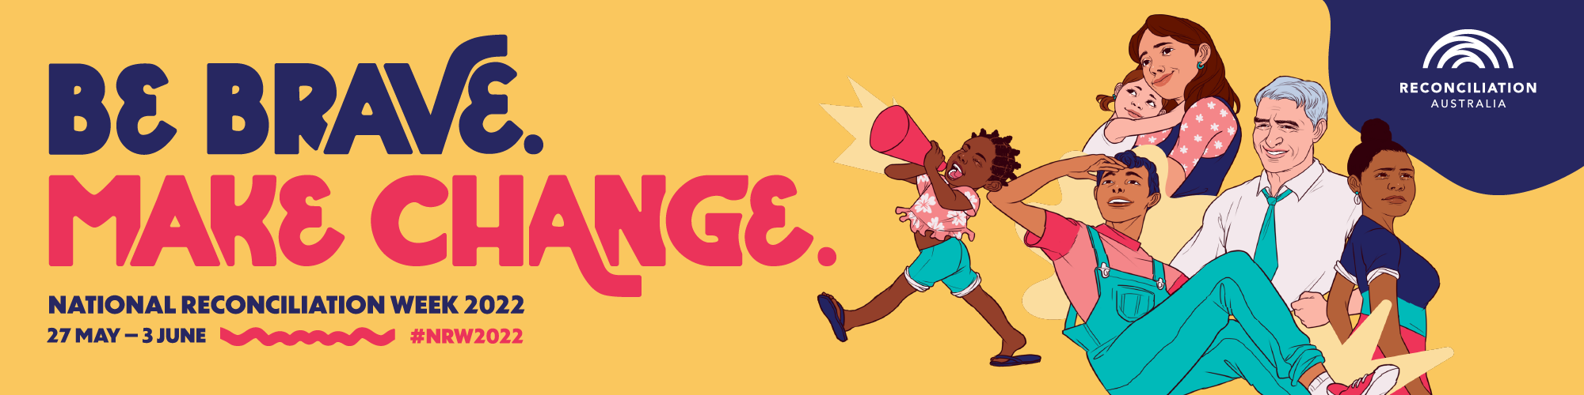

Moree reconciliation week Bridge walk
Tuesday 31st May
12pm walk from the Dhiiyaan Centre across the town bridge than
Return to rocket pack for a BBQ lunch and entertainment
For further information please call Glen on 0447800184

