MEDIA RELEASE
23 February 2022
Launch of the Burawa National Indigenous Careers Centre, to move our Mob up.
Burawa National Indigenous Careers Centre was launched this month, providing a national one stop shop for Aboriginal and Torres Strait Islander jobseekers to participate in culturally tailored free online courses. In a first of its kind approach, Burawa courses are available nationally to support career engagement and progression.
Burawa, is a Dharug word that provides one interpretation for ‘up or upwards’. The program is funded by the Federal Government National Careers Institute to deliver online short courses and non-accredited training over a three-year period.
Developed by Tranby National Indigenous Adult Education and Training (Tranby), Burawa responds to a national need for more culturally informed career training and courses, to support Indigenous career success. This innovative national model is powered by Tranby's impressive 65-year legacy of working with community and their deep knowledge of Aboriginal-controlled education as a means of empowerment and self-determination.
Until now, there has been a limited amount of clear, useful, and culturally competent information and support on vocational careers and employments pathways for Aboriginal and Torres Strait Islander peoples.
Uncle Dion Barnett, a trainer at Tranby and born on Jagera land in Brisbane (whilst his mother was born on Wulgurakaba country in North Queensland), says it’s about acknowledging the many pathways’ people take in their career, while integrating Indigenous ways of learning.
“We know that when our people are engaged and feel culturally safe, success follows. Burawa offers online courses to support people throughout their career journey, from their career entry, or returning to their career after family or cultural responsibilities through to seeking career progression or a career change,” said Uncle Dion.
Emma Griggs (Wiradjuri), Burawa’s Project Director said an integral part of the program is access to tailored mentoring for support and guidance.
“We offer tailored mentoring to support mentors throughout our programs, men and women from a variety of sectors and backgrounds that are paired with mentees as someone who has already walked the path they wish to embark on, someone to share their journey and offer that guidance,” said Emma.
The course content has been developed ensuring cultural competency throughout, delivered through narrative and supported by, visual and community links. Participants are encouraged to apply different ways of thinking to apply career pathway mapping. The program also includes leadership training, professional upskilling, and culturally safe mentor support.
Aunty Corina is a Dharug/Dharawal wagulgu guwul diyin of Sydney (Dharug/Dharawal First Nations senior woman of Sydney). Aunty Corina, a cultural and language educator of Wayali Gili, Dharug Ngurra Aboriginal Corporation and Yanama Budyari Gumada Aboriginal Corproration was engaged in the development of an appropriate language name for the program, to ignite language to the country and to people, providing cultural strength.
At present, Dharug Ngurra is working to restore and revitalise the Dharug Dhalang (language) with and for Community. Through a dynamic consultation process, Aunty Corina highlighted 'Burawa' as a word that encapsulated the meaning of the program, demonstrating the importance of education as a tool of empowerment for community.
The Burawa artwork was created by Aboriginal artist Luke Penrith, with ancestry from the Wiradjuri, Wotjobaluk, the Yuin and the Gumbaynggirr nations. Luke himself is a proud Tranby alumnus.

“I am passionate about adult education, and the role it plays in helping us be where we want to be. I was so pleased to work on this artwork, to help embed our stories into this new initiative. I wanted to represent our long traditions, of mob coming together to study, build knowledge and skills, just as our ancestors have done for thousands of years,” Luke said.
Applications are now open for 2022 non-accredited short courses, head to www.burawa.com.au for more information.
-ENDS-

Media enquires

For interviews please contact media@33creative.com.au or call Haidee Allan, 0402 560 135.

Download media images

Burawa’s Project Director, Emma Griggs (Wiradjuri) | Uncle Dion Barnett, a trainer at Tranby | Burawa artwork by Luke Penrith
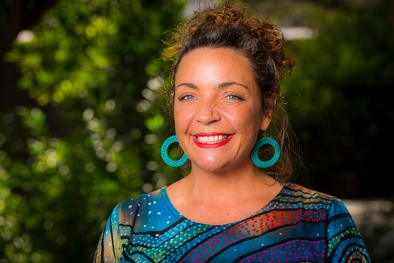 | 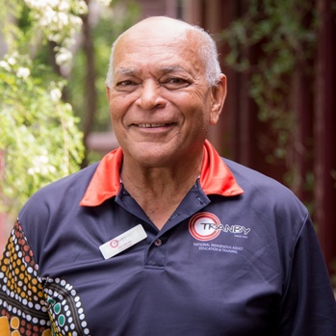 | 