Media Release | 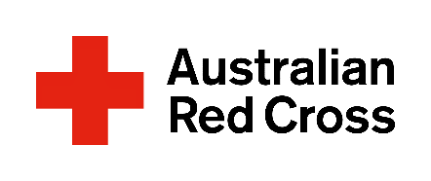
DAY DATE
Partnership to strengthen Moree communities
The Moree community’s ability to meet the challenges of the global pandemic and a changing climate has been/will be strengthened this week with a new partnership between Miyay Birray Youth Services and Australian Red Cross.
Miyay Birray Chief Executive Officer Darrel Smith said the partnership meant a community engagement officer would be dedicated to sharing information and coordinating services and resources for young people and families.
“It will give the community a focus point in times of need, and will connect them to the services and people who can help,” he said.
Miyay Birray supports the development of Aboriginal and non-Aboriginal people aged 12 to 18, working directly with young people and with their families and the community.
Mr Smith said community engagement officer Glen Crump would draw on excellent local and cultural knowledge and an ability to quickly assess and respond to needs, and would work to increase community preparedness and recovery capacity.
“For example, the liaison officer can help ensure that a family in Covid isolation has food, medical supplies, psychological support – everything they need to isolate safely at home,” he said.
Red Cross acting State Emergency Manager Mark McMullen said Red Cross was funding the community engagement position and working closely with Miyay Birray.
“We now have a partnership that will help build the capacity and capability of Red Cross to deliver community-led recovery programs with Aboriginal and Torres Strait communities affected by a changing climate and global pandemic,” he said.
“The beauty of the partnership is that it will build on relationships and trust while developing and delivering culturally appropriate preparedness, resilience and recovery programs that support the wellbeing of Aboriginal and Torres Strait Islander people and the entire community.”
Mr McMullen said Red Cross would work with Miyay Birray to:
- develop strategies and processes to help Red Cross staff and volunteers support the needs of Aboriginal and Torres Strait Islander communities
- help develop a Recovery Needs Assessment
- build on volunteer recruitment and development pathways for Aboriginal and Torres Strait Islander people
- deliver preparedness and recovery workshops and training for Aboriginal and Torres Strait Islander communities and other stakeholders.
For media queries or interview requests, contact Carolyn Varley, cvarley@redcross.org.au, 0405 761 339, or media@redcross.org.au, 1800 733 443

