JANUARY 2 0 2 2 , ISSUE 5

*Companion Guide*

A SUPPORT GUIDE FOR FAMILIES, INDIVIDUALS & COMMUNITY

**TOOLS T O HELP YOU NAVIGATE TOUGH TIMES**



Nicola Fisher - Recovery Project Officer (Northern NSW)

(Mon, Thurs, Fri) Mobile 0448 749 198 [Email: nfisher@redcross.org.au](mailto:nfisher@redcross.org.au)

**NEW YEAR**

Hello friends,

Welcome to 2022.

New Year, new beginnings.

Hope this newsletter finds you

safe and well.

I hope you find time to think about how you will honour yourself in 2022 with wellbeing and social activities that help you thrive.

We have lots of valuable topics planned in upcoming issues, but for this edition we wanted to talk about insurance as we know this is a key theme across communities. Keep reading to find out more.

Most community service

agencies, practitioners, charities, and government organisations connect regularly to share

information regarding the   
services they offer, available

grants, new projects and programs, and to discuss key impacts and emerging needs of

the community. This   
networking allows agencies to work together, regarding local activities and events, applying

for funding or even   
collaborating and contributing to tools such as this newsletter you're reading.

Community-led emergency preparedness continues to be a key focus.

Included below are some key events and activities offered by Red Cross that are focused on bringing community together to recognise existing wisdom and local expertise from past emergencies, to help plan for the future.

You know your community best, knowledge sharing is key.

You know who to call when a tree is down, your tractor has broken down, or when your cows have escaped. You know where the safest places are, clearest

telecommunications points,   
sources of water, generators, safe parking spaces, and so much more.

The purpose of these events is to harness this wisdom to ensure every resident is best equipped to help themselves and others in an event.

SES have been very busy with both storm and flood events, and also want to share some vital information, that we encourage you to read.

**Make 2022 the year you are most prepared. Most prepared for your own self-care, and most prepared to take care of you, your family and your property.**

THE HEALING CONTINUES

**JANUARY 2 0 2 2 , ISSUE 5**

**Insurance - the nitty gritty**

**Often we don't look into the fine print of our insurance policies until we are impacted by an event. There is a lot of lingo to digest including understanding terminology around the types of cover available. We know many people have had questions about inclusions and exclusions and what to do if you are unhappy about a claim. I am excited to share with you all an article by the Legal Team at the Northern Rivers Community Legal Centre, written especially for this edition of the Companion Guide, which we hope you will find helpful. Thanks to Karin and Katja for this wonderful contribution.**

**TAKE TIME T O READ THE SMALL PRINT**

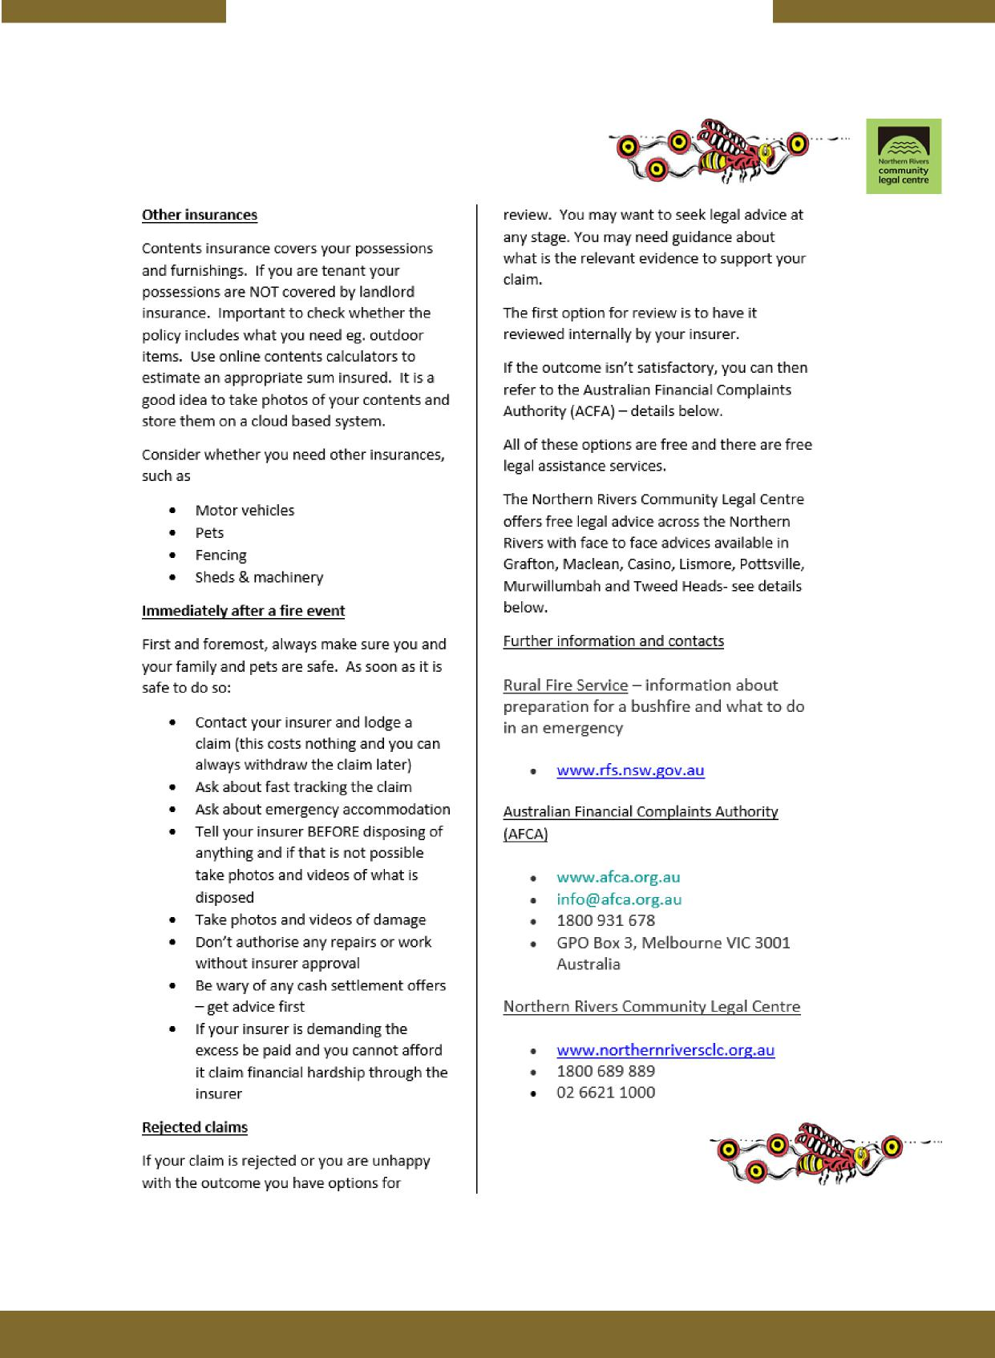

**JANUARY 2 0 2 2 , ISSUE 5**

**Insurance - the nitty gritty**

**"The Community Bee" by Patti McGurgan a Ngemba woman from Brewarrina NSW who has worked and lived on Bundjalung Country for the past 47 years. The Community Bee represents the Northern Rivers Community Legal Centre. The circles represent communities in the Northern Rivers. The community bee travels to the communities to assist with advice, help and information.”**

**SEEK ADVICE AND SUPPORT**

**JANUARY 2022, ISSUE 5**

**Red Cross activities to build**

**Community-led Resilience**

Did you feel connected when the last disaster happened or when you first moved to your community? Please find below some different ways as a resident that you can start your journey of feeling connected or helping others connect. These activities will help strengthen or begin your Community-led Resilience Team (CRT), which is a communication tree to support residents before , during and after an emergency. It can assist the vulnerable , build on skills and resources already in the community and create important relationships with Emergency Services Agencies.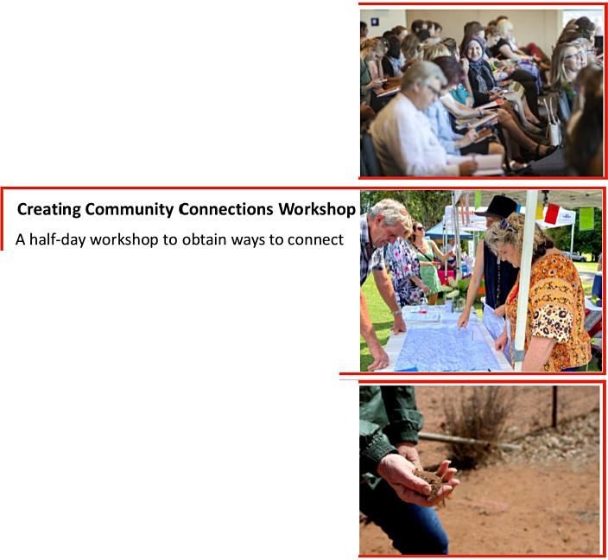

**Tales as Old as Time — Social event**

A social get together for community where residents come together to share stories. It's about older generations sharing historical information on not just emergencies but interesting stories of the past. It's a way for new residents to learn about their community.

**CRT working group Presentation**

This presentation discusses the benefits of a Community-led Resilience Team (CRT) and how being connected will assist in emergencies. It explains the CRT process and how simple it can be to get started.

to your community, identify community leaders and discuss what issues are important

to the wider community. It will help

identify risks and brainstorm ways to improve preparedness and recovery.

|  |  |
| --- | --- |
| [redcross.org.au](http://redcross.org.au) follow us A "._.e) (L:Jin  If Interested in any of the above activities, please contact Nicola Fisher  on Mobile : 0448749198 or by Email : [nfisher@redcross.org.au](mailto:nfisher@redcross.org.au) | **et.4q,„**  **ppwther22;** (7, +I  kcs9, |

|  |
| --- |
| **ENSURING COMMUNITY I S A T THE HEART O F WHAT W E D O** |

**JANUARY 2 0 2 2 , ISSUE 5**

|  |  |  |
| --- | --- | --- |
| **SES Flood & Storm Awareness** |  | **SES** |
|  |
| **NSW** STATE EMERGENCY SERVICE | |

**During a flood**

When a Flood Warning is issued, there are a few things you can do to protect your family and property:

* **N**ever drive, ride or walk through floodwater
* Stack possessions, records, stock or equipment on benches and tables, placing electrical items on top
* Secure objects that are likely to float and cause damage
* Relocate waste containers, chemicals and poisons well above floor level
* Activate your Home or Business FloodSafe Plan
* Keep listening to your local radio station for information, updates and advice
* Keep in contact with your neighbours
* Be prepared to evacuate **if** advised by emergency services
* Act early as roads may become congested or close

**GET READY FOR STORM SEASON WITH THE FOLLOWING5 STEPS**

1. Know your risk
2. Plan now for what you will do
3. Prepare your home
4. Be aware
5. look out for each other

Together it's simple to Get Ready for storm season

|  |  |  |
| --- | --- | --- |
| **GET READY/** |  | **SES** |
|  |  |

|  |  |
| --- | --- |
| ***When to call  the NSW SES*** | **MISES**  **NSW STATE EMERGENCY SERVICE** |

**32 500**

**or emergency help in flood, storm and tsunami**

**dmik. IN LIFE-THREATENING EMERGENCIES 000**

**CALL TRIPLE ZERO (000)**

*Due toflood or storm is   
anyone trapped or Injured?*

**NO**

*Has a fallen tree blocked* access? (i.e. *front door/driveway/road)*OR   
*Is* a *tree threatening to fall on your property or driveway?*OR   
*Is your property flooded or in danger of flooding?*OR   
*Is your roof damaged or Leaking?*OR   
*Is there damage to your property that you cannot fix yourself?*

**NO YES**

|  |  |  |
| --- | --- | --- |
| Contact your  insurance  company or a  private contractor  to assess and  complete the job,  or repair ityourself  if safe to do so. |  | Call the NSW SES on 132 500 |
|  | Your request for assistance wilt  be logged by our operations  centre who will giveyou a reference number. Your request will then be forwarded onto the  nearest SES unit for action. |
|  |

NSW SES Volunteers undertake temporary emergency measures   
to make your home and the situation safe. It is important   
thatyou contact eitheryour insurance company or a private   
contractor to make permanent repairs to damage resulting from   
a flood or storm orto remove any remaining debris.

YES111 Call **Triple Zero (000).**

***When to call the NSW SES***

**:•:SES**

**NSW STATE EMERGENCY SERVICE**

**132 500**

**For emergency help in flood, storm and tsu**

**9.41a IN LIFE-THREATENING EMERGENCIES 000**

**Em„ CALL TRIPLE ZERO (000)**

The *NSW SES* experiences many calls during floods and storms.

Assisting people in our communities who are overwhelmed by damage and impacts of natural disasters as quickly as possible is important to all *NSW SES* volunteers.

**What to do after logging a call with us:**

* Make sureyou keepyour phone close by so we can easily contactyou aboutyour request for assistance.
* Stay away from any fallen trees and/or power lines that may have been brought down in the storm.
* Follow any safety recommendations you are given by the *NSW SES.*
* *NSW SES* attends to request for assistance in a priority based order. A life threatening emergency will always be given immediate priority.
* If you no longer require emergency

assistance, call us on 132 500 quoting your reference number to cancel the request. This helps free up our emergency crews if you no longer need us.

**For great tips on howyou can Get Ready this Storm Season, or to find out more information about the** *NSW* **SES, head to our website at**

**I F IT'S FLOODED FORGET I T**

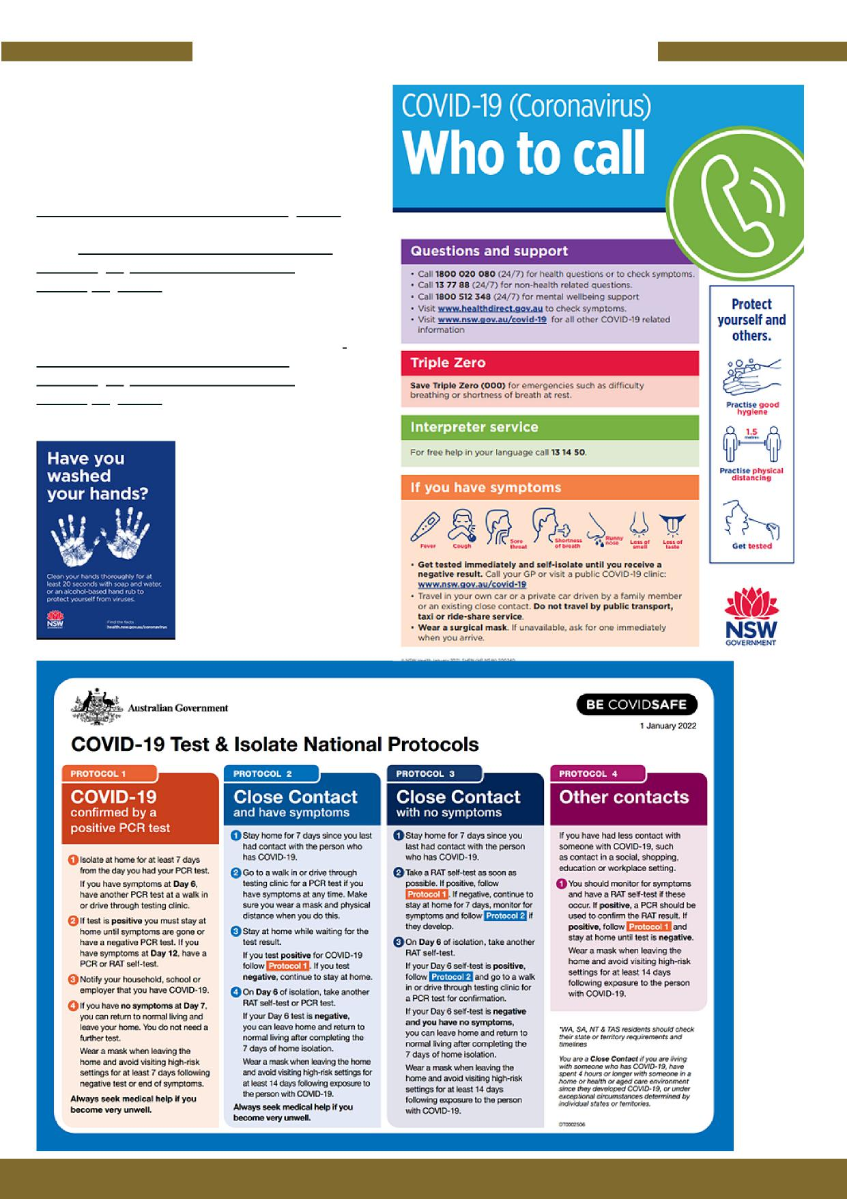

**JANUARY 2 0 2 2 , ISSUE 5**

**COVID info**

**For more information and updates about COVID-19 in your state:**

**NSW -** [**COVID-19 (Coronavirus) (nsw.gov.au)**](https://www.health.nsw.gov.au/Infectious/covid-19/Pages/default.aspx)

[**QLD - Coronavirus (COVID-19) | Health and**](https://www.qld.gov.au/health/conditions/health-alerts/coronavirus-covid-19) [**wellbeing | Queensland Government**](https://www.qld.gov.au/health/conditions/health-alerts/coronavirus-covid-19) [**(www.qld.gov.au)**](https://www.qld.gov.au/health/conditions/health-alerts/coronavirus-covid-19)

**For information and tips on health and wellbeing at home head to** [**Healthy at home —**](https://www.qld.gov.au/health/conditions/health-alerts/coronavirus-covid-19/keep-well/healthy-at-home)[**coronavirus (COVID-19) | Health and**](https://www.health.nsw.gov.au/Infectious/covid-19/Pages/default.aspx) [**wellbeing | Queensland Government**](https://www.health.nsw.gov.au/Infectious/covid-19/Pages/default.aspx) [**(www.qld.gov.au)**](https://www.health.nsw.gov.au/Infectious/covid-19/Pages/default.aspx)

**STAY SAFE**

**JANUARY 2 0 2 2 , ISSUE 5**

**Supporting Men**



**Men can register their interest on the Men’s Table website or attend an online event to see if it is something they would like** [**https://themenstable.org/start/**](https://themenstable.org/start/) **.**

**You need at least 2 blokes to start a local table and they will be helped by the organisation to promote and run their first event.**

**I T ONLY TAKES ONE PERSON T O BRING ABOUT CHANGE**

**JANUARY 2 0 2 2 , ISSUE 5**

**Events**

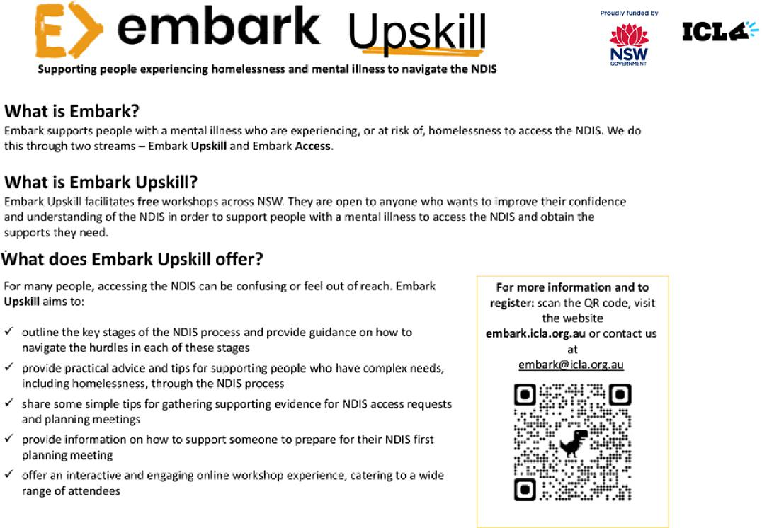

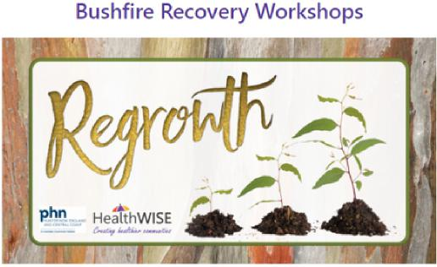

**Event Locations and dates**

**Tenterfield Wed 23rd February 2022 Wollomombi Tuesday 1st March 2022 Inverell Wednesday 23rd March 2022 Tamworth Wednesday 6th April 2022 Walcha Wednesday 18th May 2022 Bingara Wednesday 8th June 2022**

**For more information head to -**

[**H T T P S : / / H E A L T H W I S E N E N W . C O M . A U /**](https://healthwisenenw.com.au/)

**REGROWTH WORKSHOPS**

**HealthWISE will be bringing six bushfire events in 2022. These events are to bring people together socially but equally to help equip us all emotionally for any disasters ahead. Just as we prepare in a practical sense for bushfires we need to also prepare and be equipped emotionally.**

**Our events bring speakers who will give us skills to manage stress and anxiety and also provide help in the management after the crisis is over. Services will be present to explain what help and support is in the community and there will also be nurses available on the day for free health checks.**

**The theme of our day is ‘Re-growth’ of our ourselves after disaster and the importance of connection with each other.**

**WORKSHOPS**

**JANUARY 2022, ISSUE 5**

|  |  |
| --- | --- |
| **Events**  STAYING CONNECTED  WHEN EMOTIONS RUN HIGH |  |

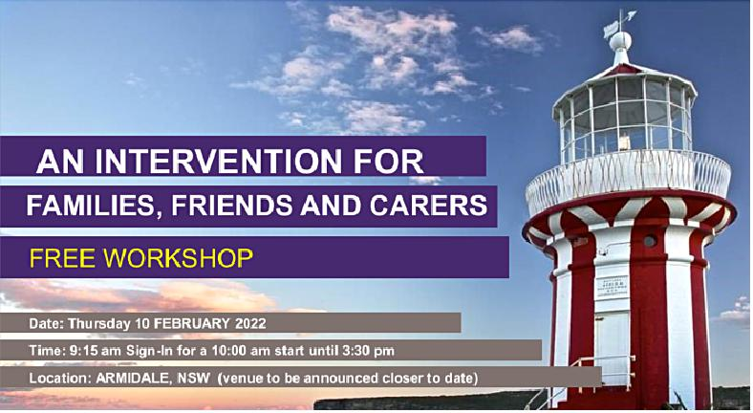

**AN INTERVENTION FOR**

**FAMILIES, FRIENDS AND CARERS**

FREE WORKSHOP

Date: Thursday **10 FEBRUARY 2022**

Time: 9:15 am Sign-In **for a 10:00** am start until 3:30 pm

Location: ARMIDALE, NSW (venue to be announced closer to **date)**

**EVENT OVERVIEW**

This FREE workshop provides carers with additional communication skills to support someone (between 12yrs to 100yrs) who experiences any of the following:

Has relationship difficulties,

Demonstrates changing emotions and strong overwhelming feelings that can make communication difficult,

Sometimes behaves in a way that makes them a danger to themselves or others.

These symptoms can be experienced in those

with mental health issues, drug and alcohol dependence, developmental disorders.

**FACILITATORS**

Dr Annemaree Bickerton

(Child, Adolescent and Family Psychiatrist)

Toni Garretty

(Clinical Coordinator Family and Carer

Program Illawarra and Shoalhaven Mental

Health Service)

Thurs 10th FEBRUARY 10am — 3:30 pm 9:15 am sign in + morning tea-**10** am start

Morning tea upon arrival, lunch and afternoon tea provided

Please register your interest with   
Isabelle 0400 463 171 or

[isabelle.deyosonedoororq.au](http://isabelle.deyosonedoororq.au)

[t_0.frt 74:01 One **DOOR** I meres PSI% *C.vee* SeNr.ce,..

One Door. Many Opportunities. [onedoor.org.au](http://onedoor.org.au) 0400 463 171

**CARERS SUPPORT**

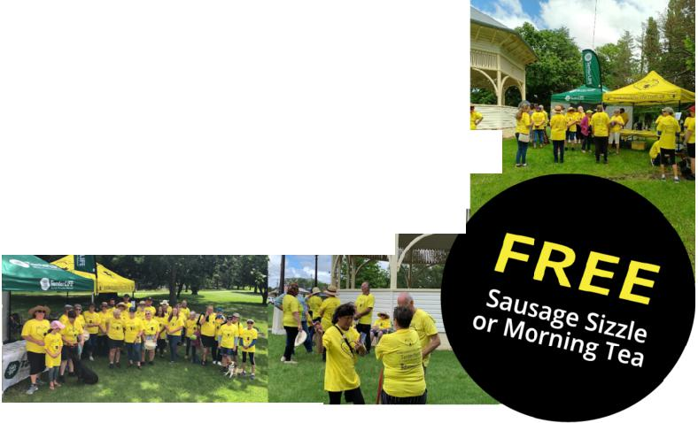

**TENTERFIELD**

**JANUARY 2 0 2 2 , I S S U E 5**

**Events**

*We practice safe social distancing at our events*

*Walk ai-ld Talk Your Woi-e;ec Away*

Everybody is welccme to this tree event including dogs!

Come down, grab a free yellow T-shirt and join **I** Walk `n' Talk For Life's growing community

I ***Wag***

***Talk Foe-*** *(11:j*

Connect with your community to raise awareness for

mental health and to prevent suicide



**I' YIVIFIIF**

**4th Sunday of each month**

**Jan 23rd, Feb 27th, Mar 27th, Apr 24th, May 22nd & June 26th**

Meet at 9.30am for the walk to begin at 10am from Jubilee Park, Manners St, Tenterfield

Each month different Tenterfield Community   
groups will sponsor the morning tea/sausage sizzle.



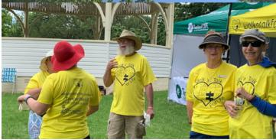

OLIKE OUR FACEBOOK PAGE [www.facebook.com/walkntalkforlifeTenterfield](http://www.facebook.com/walkntalkforlifeTenterfield)

[www.walkntalkforlife.com.au](http://www.walkntalkforlife.com.au)

**SUPPORTING SELF AND SUPPORTING OTHERS**

JANUARY 2 0 2 2 , ISSUE 5

**Suggest a topic for**

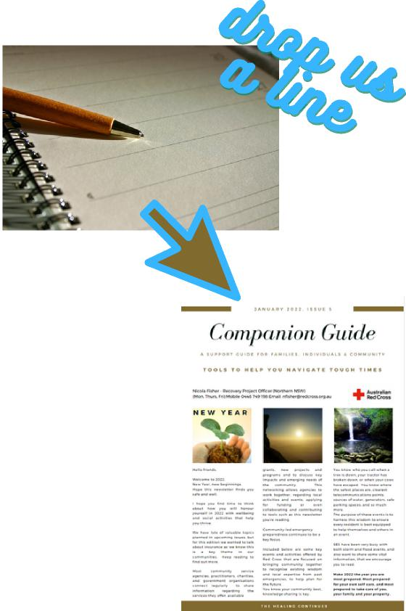



**the next edition**

Do you have an idea or suggestion about content for a future newsletter edition? Drop us a line.

We have covered a variety of topics relating to recovery, resilience and community readiness in this newsletter and would love to know what else you think we should include.

What are you hearing and seeing as common themes, or needs in your community?

Nicola Fisher - Recovery Project Officer

(Northern NSW)

Mobile 0448 749 198

[Email: nfisher@redcross.org.au](mailto:nfisher@redcross.org.au)

**Life Lines**

**Lifeline** - Phone: 13 11 14 (24 hrs / 7 days)

Provides 24-hour crisis counselling, support groups

and suicide prevention services.

Text: 0477 13 11 14 (12pm – 2am AEST)

Chat online: <https://www.lifeline.org.au/crisis-chat>

**Beyond Blue** - Phone 1300 22 4636 (24 hrs / 7 days) Provides info and support to help everyone achieve their best mental health. For COVID mental health support Phone 1800 512 348 (24 hours / 7 days) Online forums 24 hours a day/ 7 days a week Chat Online (11am – 12am AEST / 7 days)

**Headspace** -1800 650 890

A Free online and telephone service that supports

young people aged 12 - 25 years, and their families.

**Kids Helpline** - 1800 55 1800

A free, private and confidential, telephone and online counselling service specifically for young people aged between 5 and 25 years.

**MensLine Australia** - 1300 78 99 78

Telephone and online support, helping men to deal with relationship problems in a practical and effective way.

**1800RESPECT** 1800 737 732 (24hrs / 7 days) Confidential information, counselling and support service for people impacted by sexual assault, domestic or family violence and abuse.

**QLife** - 1800 184 527 3pm-12am

Counselling and referral service for LGBTI+ people.

**Relationships Australia** - 1300 364 277 Relationship support services for individuals, families and communities.

**SANE Australia** - 1800 18 7263

Information about mental illness, treatments, and

where to go for support

**National Alcohol and Other Drug Hotline** Phone - 1800 250 015

A 24/7 free and confidential hotline for anyone affected by alcohol or other drugs.

**Suicide Call Back Service** - Call 1300 659 467. Provides 24/7 support if you or someone you know is feeling suicidal.

|  |
| --- |
| ASK FOR WHAT YOU NEED |